Module pos.utils.dynamic_import Reference

Scope

Intended Use and Functionality

Design and Implementation

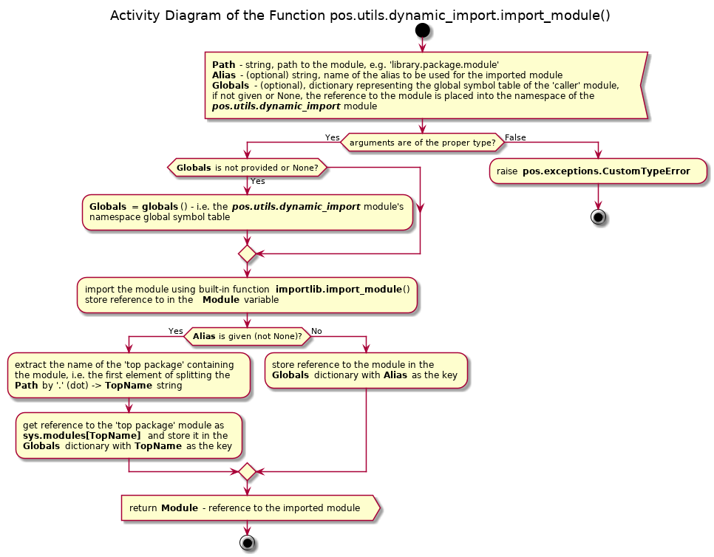Illustration 1

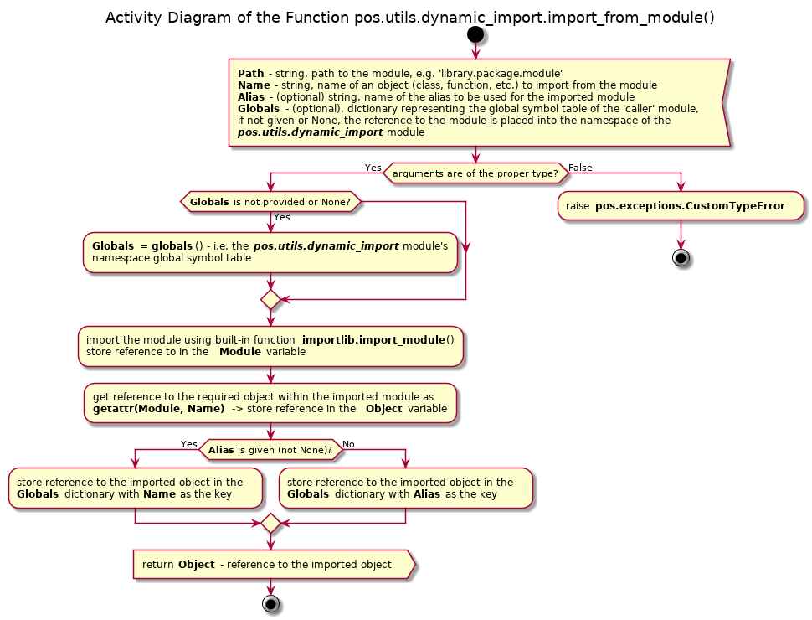Illustration 2

API Reference

Functions
import_module(strPath, strAlias = None, dictGlobals = None)
str/, str, dict/ -> __builtins__.module
Dynamic import of a module, optionally, with aliasing of its name. In order to place the reference to the imported module into the global symbol table of the caller's module such table must be passed as the keyword argument 'dictGlobals' or a the third positional argument; otherwise the reference
to the module is placed into the global symbol table of the module pos.utils.dynamic_import itself.

Args:
strPath: string, path to a module, e.g. 'library.package.module'
strAlias: (optional) string, alias to be assigned to the imported module
dictGlobals: (optional) dictionary representing the global symbol table

Returns:
__builtins__.module: a reference to the imported module

Raises:
pos.exceptions.CustomTypeError: passed path to the module is not a string; or passed alias is not a string or None; or the passed global symbols table is not a dictionary or None
ImportError: required module is not found

import_from_module(strPath, strName, strAlias = None, dictGlobals = None)
str, str/, str, dict/ -> type A
Dynamic import of an object from a module, optionally, with aliasing of its name. In order to place the reference to the imported object into the global symbol table of the caller's module such table must be passed as the keyword argument 'dictGlobals' or a the fourth positional argument; otherwise the reference to the object is placed into the global symbol table of the module pos.utils.dynamic_import itself.

Args:
strPath: string, path to a module, e.g. 'library.package.module'
strName: name of an object defined in the module, e.g. 'SomeClass'
strAlias: (optional) string, alias to be assigned to the imported object
dictGlobals: (optional) dictionary representing the global symbol table

Returns:
type A: a reference to the imported object

Raises:
pos.exceptions.CustomTypeError: passed path to the module is not a string; or passed name of the object is not a string; or the passed alias is not a string or None; or the passed global symbols table is not a dictionary or None
ImportError: required module is not found
AttributeError: required object is not found in the module

